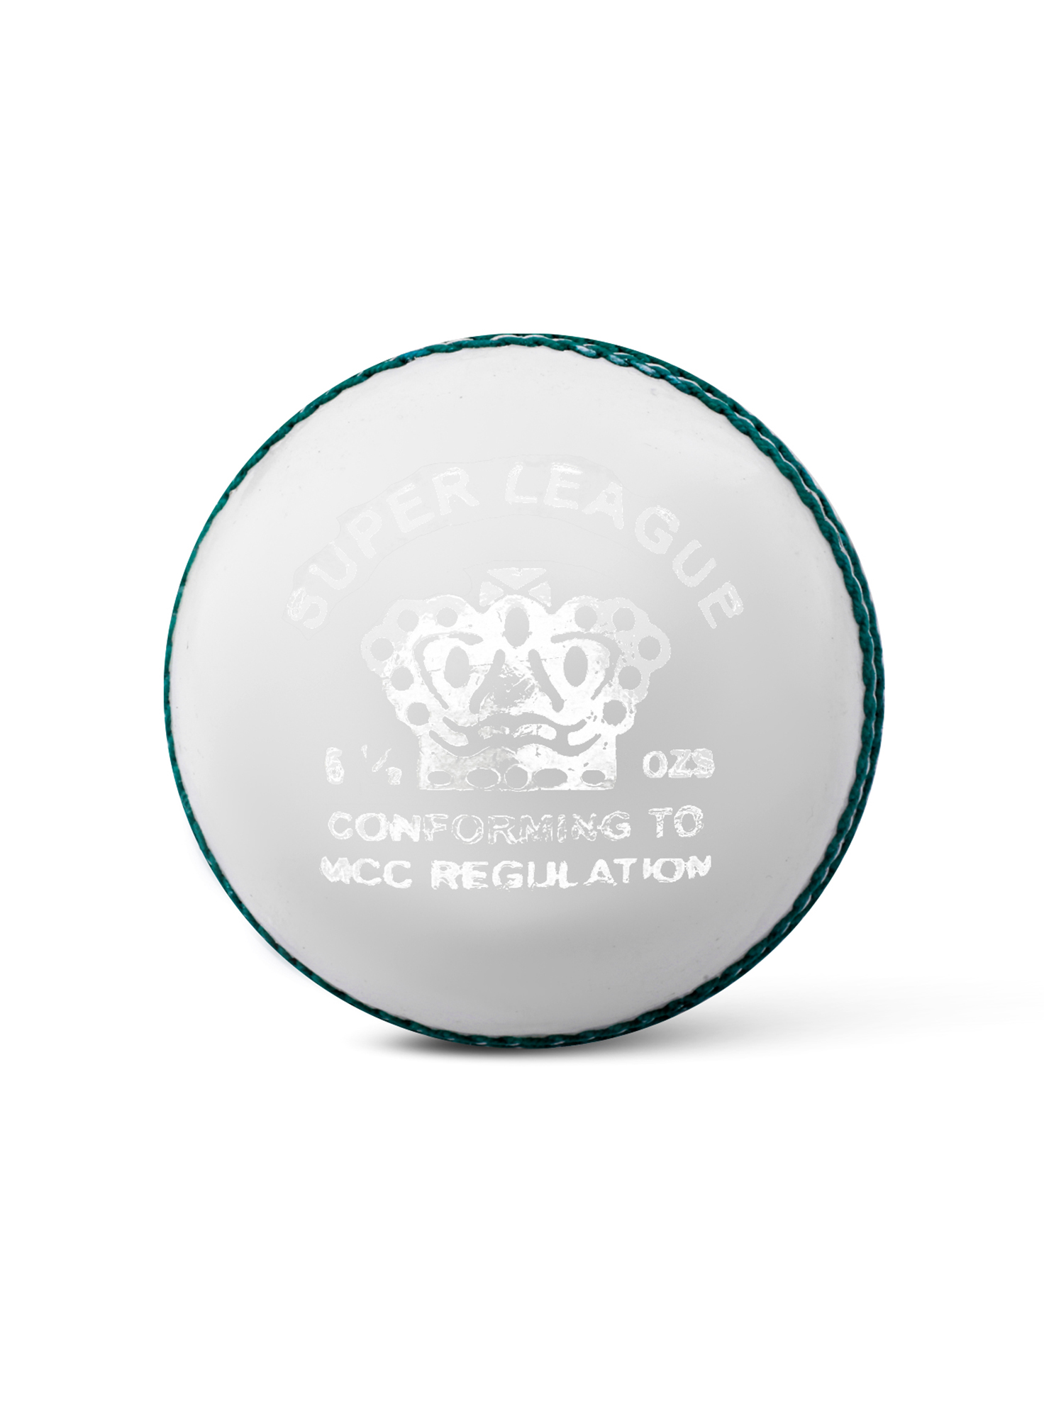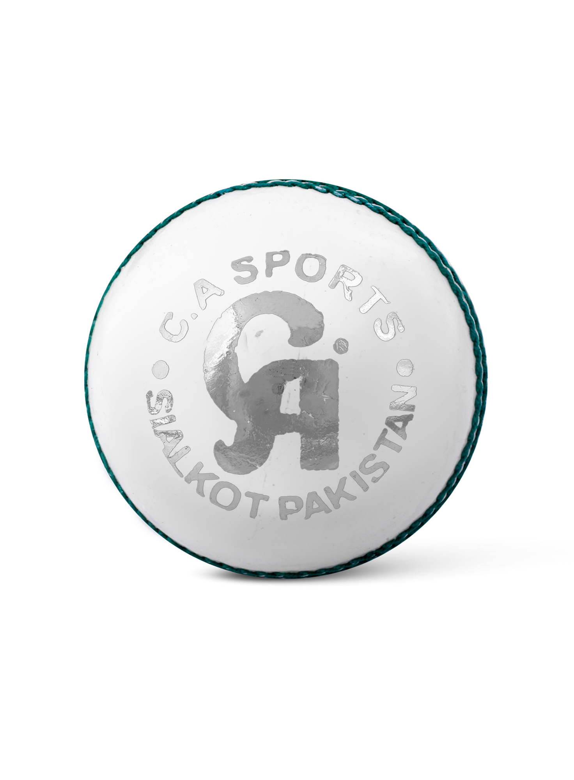

CA SPORTS SUPER LEAGUE WHITE BALL

Designed to deliver superb performance and durability, CA super league cricket ball is a great option for club, practice, and school matches.

**DETAILS:**

* Good Quality Chrome Leather
* Cork Layers & Wool Bonding.
* PVC Center Hand Stitched
* Suitable For 50 over Games.
* 4 Pieces Construction